NERIS Working Group on “Information, participation and communication” (IPC WG) in Emergency Preparedness and Response (EPR)

Meeting 2. Oxford, September 19, 2016

List of Participants:
- Mario REIS (IST)
- Isabel PAIVA (IST)
- Pedro VAZ (IST)
- Wolfgang RASKOB (KIT)
- Nobuaki MORIYAMA (Hiroshima University)
- Pascal CROUAIL (CEPN)
- Stéphane BAUDÉ (MUTADIS)
- Tatiana DURANOVA (VUJE)
- Maarit MUIKKU (STUK)
- Sylvie CHARRON (IRSN)
- Milagros MONTERO (CIEMAT)
- Gaston MESKEMS (SCK-CEN)
- Marie-Claire CANTONE (UMIL)
- Octavia MONTERO GIL (IST)
- Tanja PERKO (SCK-CEN)
- Nadia ZELEZNIK (REC)
- Meritxell MARTELL (MERIENCE)
- Caroline SCHIEBERT (CEPN)
- Christiane PÖLZL-VIOL
- Mélanie MAÎTRE (CEPN)
- Eduardo GALLEGO (UPM)

Introduction

The meeting was held in Oxford, during the Radiation Protection Week 2016. 21 persons attended (see attendance sheet in Annex 1).

This meeting started with the presentation of Nobuaki MORIYAMA (see Annex 2) who is a current PhD student at the Phoenix Leader Education Program. In the framework of the Fukushima accident, his research is dedicated to understand precisely the status of revitalization in recovered area (particularly in Okada – Minamisoma city), and the concerns and expectations of former residents.

Then, the discussion was focused on the implementation of the “Topics to be considered” by the WG and on the actions to be developed in the following months, in order to start reaching the WG objectives. The initial topics of the WG, as discussed at the meeting in Bratislava, were reminded:

- Information and participation of the public.
  - Communication among experts and stakeholders
  - To support the local participation and gathering of information
  - Interaction with traditional media and journalists
  - Role of social media

- Disseminate and use the Analytical Platform (AP)
  - Consider it as a tool for the WG, which can act as users and testers
  - The AP is unofficial, but could be connected to EC systems like ECURIE, EURDEP to increase coordination of information and transparency. JRC can have a key role.
  - Users will be researchers, NGOs, stakeholders… and the public
  - Use it for research, training, analysis of scenarios and improve EPR …

- Interaction and exchange of experience between experts:
  - Networking experts
  - Feedback from the ICRP Dialogues in Fukushima (http://www.icrp.org/page.asp?id=189 )
  - Interaction with the Eagle Platform (http://eagle.sckcen.be/ )
  - Use of the AP to create a forum for experts

- Elements, tools or processes that can facilitate the EPR of local stakeholders
  - Information of the public for preparedness
  - Preparation, compilation, of easy-to-understand materials on scientific knowledge about radiation risk, nuclear accidents and radiological events
  - Interaction with the stakeholders (for instance, through stakeholder panels, like those formed in WP3 – WG ConGoo)

After an animated discussion, different proposals were made and the agreement of starting actions was reached as follows. Only the actions are listed. The AP Forum will be used in the coming weeks to improve the contents of each action and detail the implementation plans, as well as to identify leaders of each action.

Actions for the IPC WG:
 | Description | Leader | Starting date
1 | KIT to provide access to the AP to WG members. The initial login credentials will be based on email addresses. | W. Raskob  E. Gallego | Sept. 2016
2 | Establishing a forum for the WG in the AP.  Starting discussion of topics (see topics below) | - Gallego | Sept. 2016
3 | Drafting and editing easy-to-read leaflets (no more than 4 pages each) with the key messages from PREPARE WP6 and WP3:  - Several leaflets for different target stakeholders were suggested:  - RP authorities;  - EPR management;  - emergency responders;  - Population living near NPPs;  - Journalists;  - Members of ConGoo national stakeholders panels;  - International organizations.
4 | Develop new sections on the NERIS website:  - With relevant deliverables from previous projects: EURANOS; NERIS-TP; PREPARE  - With newly edited information to stakeholders (see above)  - ConGoo WG: sharing materials and conclusions from the national stakeholder panels  - Links (and maybe reproduction) of relevant deliverables and publications from related projects (EAGLE, …) | NERIS Secretariat | Sept. 2016
5 | Starting NERIS presence in social networks (Facebook; Twitter; …).
6 | Compiling lists of potential target NERIS stakeholders. With collaboration of all NERIS members. | NERIS Secretariat
7 | Maintain and increase the visibility of NERIS at international meetings (IAEA; IRPA; NEA, NTW …)  - For instance: NTW meeting on Euratom articles about information to the public in EPR areas and Aarhus Convention Workshops.  - … | All NERIS members can send information about events related to NERIS activity to the NERIS Secretariat (sec@eu-neris.net).  Then, the NERIS MB will decide if it is appropriate to have a NERIS representation. | Sept 2016
8 | Organise a training session on the AP during the NERIS Workshop in Lisbon, May 2017.
9 | Next WG meeting during the NERIS Workshop in Lisbon May 2017

Annex 1

Participants at the meeting:

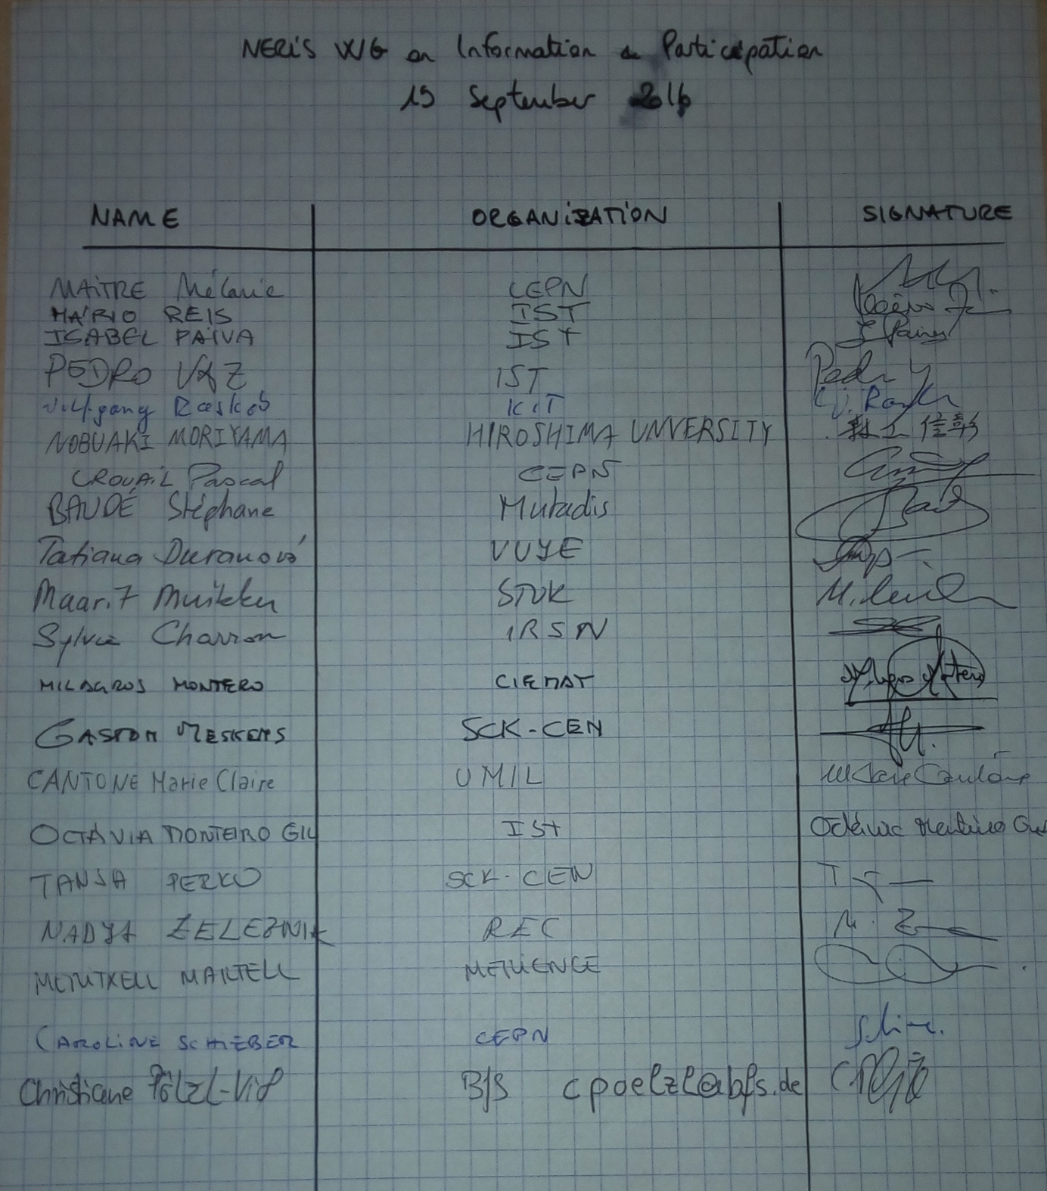

+ Eduardo GALLEGO, UPM.

Initial participants at the WG:

- Leader: Eduardo Gallego, UPM (could lead the WG at the starting point)
- Stéphane Baudé, Mutadis, France
- Gilles Hériard-Dubreuil, Mutadis, France
- Marie Claire Cantone, University of Milano, Italy
- Sylvie Charron, IRSN, France
- Tatiana Duranova, VUJE, Slovakia
- Inger Eikelmann, NRPA, Norway
- Julie Hazemann, Enerwebwatch - COOPANAME, France
- Andreas Ikonomopoulos, NCSR, Greece
- Montserrat Marín Ferrer, EC-JRC (Ispra, Italy)
- Joao Oliveira Martins, Portuguese Environment Agency (PAA), Portugal
- Paulo Nunes, Portuguese Environment Agency (PAA), Portugal
- Luis Portugal, Portuguese Environment Agency (PAA), Portugal
- Isabel Paiva, Instituto Superior Técnico (IST), Portugal
- Mário Reis, Instituto Superior Técnico (IST), Portugal
- Milagros Montero, CIEMAT, Spain
- Cristina Trueba, CIEMAT, Spain
- Christophe Murith, Federal Office for Public Health, Switzerland
- Catherine Organo, Environmental Protection Agency, Ireland
- Tanja Perko, SCK-CEN, Belgium
- Wolfgang Raskob, KIT, Germany
- Matthias Zaehringer, BfS, Germany
- Nadja Železnik, Regional Environmental Center, Slovenia, and NTW President
- ….. , CRIEPI, Japan
- …
- Other international experts who have experience in Fukushima

Annex 2

