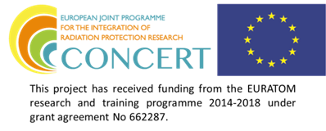

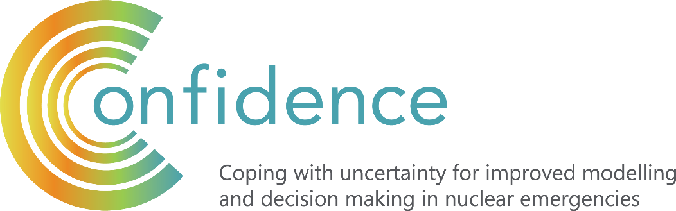

Uncertainty in nuclear or radiological emergency management
should be admitted and communicated.

The more uncertain the information, the more communication is needed.

Uncertainties can be reported in verbal, numeric, graphical or digital form. It is possible and advisable in some circumstances to use all of them simultaneously.

Communication tools and messages should be developed and tested before an emergency.

How to communicate about uncertainty?
Selected CONFIDENCE guidelines

Within CONFIDENCE an extensive research programme has been conducted on a range of different tools, including Apps, SMS, maps, numerical, narrative or mixed messages and videos linked to uncertainty communication following potential nuclear or radiological emergencies. Based on the overall results of these studies, we have formulated guidelines for efficient and effective communication about uncertainties. The details of this research are presented in Perko at al (2019), while this leaflet uses results to formulate some “”first hand guidelines” for efficient and effective communication about uncertainties that can be used in nuclear or radiological emergencies.

Please, use the following reference: T. Perko, Benighaus L., Tafili V., Oughton D., Tomkiv Y. , Sala R., Germán S., López S., Oltra C., Duranova T., Raskob W., Müller T. , Wolf H.V., Thijssen P., Turcanu C. , Benighaus C., Moschner J., Renn, O. (2019, p. 9-12): Guidelines on tools for communication of uncertainties, D9.29, Ref. Ares(2019)6806809 - 04/11/2019, CONFIDENCE, EC, Brussels, Belgium. https://www.concert-h2020.eu/en/Publications

Communicating uncertainty requires that the facts relevant to recipients’ decisions are identified, that the relevant uncertainties are characterized and their magnitude assessed, and that possible messages are drafted and their success evaluated (Fischhoff & Davis, 2014, p. 13671).

General suggestions on communicating uncertainty

“Uncertainty communication needs to be strategic, meaning that it should follow the objectives of emergency management and planning. It should be theory based with respect to, for example, behavior, information processing, social science, risk communication, and evidence-based in the sense that is should use empirical data, surveys, or experiments. It should not be based on gut feelings and subjective opinions on “what may work” or what experts “would like to tell”. This means that uncertainty communicators need to consider public perceptions, motivations, information needs, expectations and concerns, all of which are likely to differ from experts. In addition, authorities and scientists (both natural and social) need to collaborate in order to communicate uncertainty successfully.” (Perko et. al, 2019 – CONFIDENCE D 9.29)

- Decision-making involves uncertainty. Uncertainty in nuclear or radiological emergency management should be admitted and communicated. The more uncertain the information, the more communication is needed.
- Be honest and open about what you do not know.

Many words and expressions of common language can be used to express uncertainties. You can use the following words to express uncertainty: “preliminary findings”, “based on current measurements”, ”based on current insights”, “as a first assessment”, “further measurements are needed”, “there is considerable trust in …”, “many experts and scientists consider …”, “it is widely held that …”, “likely”, “probably”, “not certain”, “may”, “might”, “seem”, …

- Uncertainties can be reported in verbal, numeric, graphical or digital form. It is possible and advisable in some circumstances to use all of them simultaneously.
- Information on the following types of uncertainties that present in nuclear or radiological management

may be communicated: nature of uncertainties, magnitude of uncertainties, conflicting scientific evidence, scientific controversies, moral, societal, legal and other contextual uncertainties, statistical uncertainties, scenario uncertainties, level of theoretical understanding, level of empirical information (e.g., the empirical data that are lacking), quality of data, quality of model structure, limitations of methods, choices with respect to indicators, points of departure, important assumptions and practical limitations (e.g., the availability of iodine pills).

When describing risks, be aware of the framing effects of wording, for example the use of the word “lives lost” versus “lives saved”.

When explaining protective measures use positive dominance, for example: “drink only bottled water” instead of “don’t use tap water”.

- Aim for emergency management decisions that are robust with respect to the underlying uncertainties.

How Apps can be used in communication about uncertainties
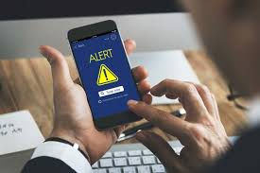
- Applying Apps for nuclear or radiological communication is nowadays inevitable.
- Develop systems and Apps solely for the purpose of nuclear safety or integrate them into existing systems that are already used to inform and warn public about natural disasters like floods, fires and extreme weather conditions, after accidents in chemical factories, and attacks.
- Carefully select which Apps to apply since there is a broad selection of existing technical tools, but the overall quality and the functionality of the different Apps vary greatly.
- Given the great potential for a targeted use of various Apps for communicating uncertainty in the case of nuclear accidents, this topic should be further investigated.
- Be aware of following issues related to Apps: False alerts, Costs (more costly than developing web-based information), Labour demanding (frequently updates necessary for App), Tedious (people do not download the App as they find it time consuming).

Content of the SMS should warn people, (e.g. “Warning!”), clearly indicate what happened (e.g. “Accident at ABC Nuclear power plan”) and where (e.g. “in place, country”). Uncertainty should be expressed (e. g. “Release of radioactivity not yet confirmed”) and the message should tell people what to do (e.g. “Stay inside, close windows and shut down ventilation system”). People should be informed about where they can get more information (e.g. “Listen to local news, check updates at hyperlink”). The name of the organization behind the SMS should be included in the message, e.g. “Federal crisis center”.
How to formulate short text messages for emergency warnings

- To inform or to warn local residents and general population by using SMS (short text messages) is a rather new and effective communication practice among early notification systems. People nowadays use mobile telephones and smart phones constantly, thus this type of system could effectively warn people about the ongoing emergency.
- The SMS should be strategically predesigned and methodologically tested before the application. Specific attention should be paid to the information needs of residents and their understanding of the message.
- Send the SMS in local language but also in English language.
- The optimal length of the SMS is approximately 200 characters, but the specificity of the local language should be taken into account.
- In the early phase of an emergency, there will be a need to communicate uncertain information like extent of damage and release of radioactivity. Therefore, frequent updates (like sending several messages) on the situation will be required and hyperlinks to additional communication means should be included.
- SMS should be designed for each country and each nuclear power plant (e.g. name of the NPP).

Visualisation of uncertainties through maps

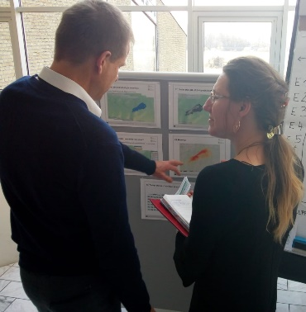
- In order to aid the decision-making on the various countermeasures, a range of additional information should be available on maps besides the radiological situation (e.g. cities, population size, roads, drinking water reservoirs, evacuation routes etc.). However, since it is also important to keep the maps simple, interactive interfaces where different layers with additional information could be turned on and off when needed should be available.
- The design of the maps should be carefully thought through to make sure that it represents information in the most comprehensive way. The choice of color coding should take into account existing color codes that are already in use, the way different colors are perceived by people (e.g. red=danger); it should have enough contrast with the base map and be visible for people with disabilities.
- Maps should include informative legends with supplementary information on uncertainty among other things.
- It is extremely hard for people who are not used to maps and have not received any training to start using them in an emergency situation. Therefore, appropriate training and exercises for the use of maps are needed for the various stakeholders that will need to be involved in the decision-making.
- Where possible, uncertainty should be indicated on the maps and there are several solutions to how these could be presented, for example by varying brightness of colors, level of transparency and color saturation, using glyphs and error bars. However, this representation will have to be situation-specific, since the CONFIDENCE studies suggested that even the expert participants were unable to articulate what their preferred uncertainty visualization methods were because they were convinced that this strongly depends on the task.
- As part of further research work, a set of four topics targeting format, design data and uncertainty could serve as an analytical tool, to further investigate reasons for potential misinterpretations and misleading information.

How to communicate about uncertainties related to the consumption of food products
Despite increased attempts to dispute numerical evidence, overall, the numerical message about radioactivity in food and safe consumption in a radiologically not affected country, it is perceived as more credible, and thus more persuasive, by the receiver than a narrative message. For instance:
“Below legal limit of 100 Becquerel per kilogram, yet Fukushima’s farmers still battle stigma” and “Beans from Fukushima contained 6 Becquerel per kilogram – a negligible dose of radiation” is believed to be more credible and is more persuasive as the narrative message “Fukushima farmers: Our vegetables are safe to eat, yet we still battle stigma”. (ref. Wolf H.V., Perko T. and Thijssen P. (2020) Journal of Environmental Communication (accepted for publication).
- Provide precise, but clear and unambiguous numerical data to support your communication in order to enhance a message’s credibility vis-à-vis the public. A few well-chosen numbers may represent the most adequate strategy in eliciting positive reactions.
- Target subgroups of the population to enhance overall persuasion levels. If an assessment of issue attitudes among a population is possible, we suggest to intensify communication to those consumers who are inclined to be critical towards the given issue, whereas those with a more positive stance might need less frequent messages in order to be persuaded.
- Consumers with a critical attitude towards the food industry and nuclear energy, for instance, may need to be provided with more and different types of evidence in order to change behavior (such as the boycott of a safe-to-consume product). Furthermore, efforts towards enhancing the public’s trust in authorities should be undertaken, as low levels of trust may inhibit consumers readiness to accept a communicated message.
- Provide numerical data if the threat related to the communicated message is distant rather than imminent. This includes risk communication that aims to prepare for nuclear emergencies. If a threat is imminent, such as an acute food risk, we suggest to broaden the scope of messages by also providing more emotionally-involving messages, such as personal testimonies.

How to communicate about uncertainties related to a time of the iodine pills uptake

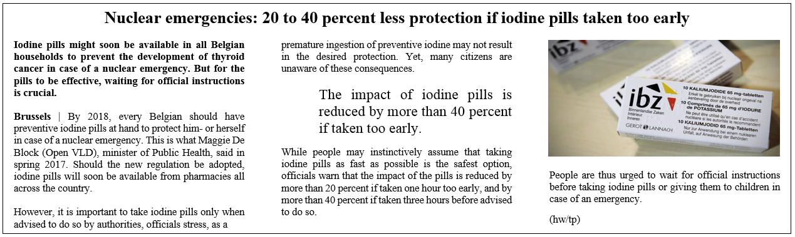
- When recommending the intake of iodine pills, communicate clearly not only a foreseen time of the intake (e.g. “wait for instructions on when to take the pill”) but also why one needs to wait with the intake (e.g. “20 to 40 percent less protection if iodine pills are taken too early”).
- The question of why to wait with the uptake can be communicated in numerical, narrative or a mixed way. For instance “Iodine pills protect far less if taken too early, xy (name and expertise of a trusted source e.g. family doctor)” or “The impact of iodine pills is reduced by more than 40 percent if taken too early”.
- Make sure that messages are repeated many times on many different communication channels – the one message, many voices, rule.

How to address uncertainty in waiting rooms

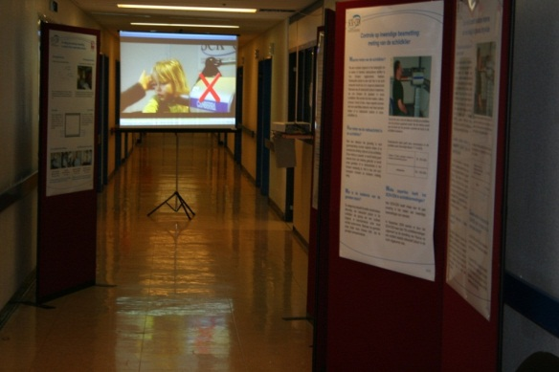
- The standard information that has to be communicated in waiting rooms (decontamination center, emergency rooms, measurement room etc.) includes the following: What is radiation and what is contamination; Health symptoms of radiation; Description of the decontamination process; Radionuclides e.g. ¹³¹I , ¹³⁷Cs, ¹³⁶Cs, ⁶⁰Co for the different types of accidents; Explanation on how internal or external contamination is measured; Identification and the expertise of institution that is providing measurement service; Efficacy of processes, for instance decontamination…
- The information material should be designed in a way that people in a stressful situation can process it: that they can understand, comprehend, and remember the information. Use not a complex terms and explanations (e.g. “Contamination is like being wet from the rain and irradiation is like sunbathing”); formulate positive statements (e.g. “Drink only bottled water” instead of “Don’t drink tap water”); address psychometric risk characteristics (e.g.: familiarity “Germanium detector measures potential radiation on the same way as thermometer measures body temperature”, dread characteristic, e.g. break down the process in different steps e.g. First you will do this, then you go there, followed by…”; effect on children e.g. use images of children at the communication material)
- Communication tools in waiting rooms should be in diverse formats: leaflets, posters, videos, and other multimedia. Face to face communication is the most efficient, but also the most resource-consuming.
- Create video material, which can inform people in the waiting room about how measurements will be done and what will be measured in the next room and by whom these measurements will be performed.

Do you wish to hear more about the research
or to organize the CONFIDENCE communication course?

Contact Tanja Perko, SCK-CEN, Belgium at Tanja.Perko@sckcen.be

or any other author of D2.29: Benighaus L., Tafili V., Oughton D., Tomkiv Y. , Sala R., Germán S., López S., Oltra C., Duranova T., Raskob W., Müller T. , Wolf H.V., Thijssen P., Turcanu C. , Benighaus C., Moschner J., Renn, O. (2019, p. 9-12):

