6th International Symposium on
Ethics of Environmental Health
České Budějovice, 8 – 11 September 2024

Sponsored by
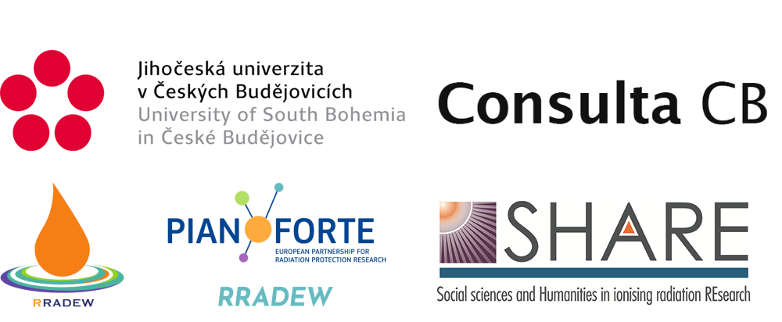

Environmental health encompasses the assessment and control of factors external to the human body that can potentially affect the health. Such factors include radiation, synthetic chemicals, and other hazardous agents. The ethical frameworks that underly environmental health research and practice, providing for rational regulatory frameworks, are not always made explicit and require continual updating and attention as technological, social, and legislative norms evolve.

We look forward to the contributions of colleagues from the whole range of environmental health research and practice to this theme. Their focus will be on the ethical implications of science and technology as they impinge on the application of research findings in the regulatory and policy domains.

The 6th International Symposium on the Ethics of Environmental Health will be held in conjunction with a workshop on “Ethics of Environmental Health in Armed Conflict Situations,” which is organised as part of RRADEW ("Resilience to RADiological Events in Wartime"), a project supported by PIANOFORTE ("European Partnership for Radiation Protection Research.") Co-sponsors will be SHARE (a European Network for "Social Sciences and Humanities in ionising radiation REsearch") and the University of South Bohemia.

PROGRAMME

Sunday, September 8, 2024

18:00 – 18:30 Registration

18:30 – 19:30 Barbecue

19:30 – 19:45 Opening

19:45 – 20:30 Insights From the “New Humanism” Symposium in Dublin, May 2024
Jim Malone, Dublin, Ireland

Monday, September 9, 2024

9:00 – 9:45 The Social, Legal, and Scientific Context for Ethical Conduct in Public Health Research and Practice
Colin Soskolne, Edmonton and Montreal, Canada
9:45– 10:30 From Fair to Care
Deborah Oughton, Ås, Norway

10:30 – 11:00 Coffee Break

11:00 – 11:30 Environmental Health in Social Work
Jitka Vacková, České Budějovice, Czech Republic
11:30 – 12:00 One Health and its Significance in an Interconnected World
Saeed Ahmad, Tampere, Finland
12:00 – 12:30 How to Balance Human Health and Environmental Integrity
Friedo Zölzer, České Budějovice, Czech Republic

12:30 – 13:30 Lunch

13:30 – 14:00 Empowering Collaborative Governance Through Open Nuclear Waste Dialogue
Nicole Martinez, Clemson, USA
14:00 – 14:30 Democratisation of Technological Development
Ehsan Arzroomchilar, České Budějovice, Czech Republic
14:30 – 15:00 Engineering Ethics Education Seen Through an Ethics of Environmental Health Lens
Tom Børsen, Aalborg, Denmark

15:00 - 15:30 Coffee Break

15:30 – 16:00 Post-disaster Ethics: Some Current Challenges Facing Fukushima Residents
Jacques Lochard, Nagasaki, Japan, and Thierry Schneider, Fontenay-aux-Roses, France
16:00 – 16:30 The Only Thing We Have To Fear Is The Fear of Radiation Itself? From a Psychological to Economic Framing of Science Communication After Nuclear Disasters
Makoto Takahashi, Amsterdam, The Netherlands
16:30 – 17:00 Radiophobia and Mysticism. Ukrainians' Perception of the Chornobyl Disaster Through Art
Oksana Semenik, Kyjiv, Ukraine

17:30 Excursion, including dinner

Tuesday, September 10, 2024

9:00 – 9:30 The RRADEW Project – An Overview
Pascal Crouail, Fontenay-aux-Roses, France
9:30 – 10:00 Scenarios of Accidents at Nuclear Facilities During Wartime
NN, Kyiv, Ukraine
10:00 – 10:30 Operational Choices for First Responders in Armed Conflicts
Denis Giordan, Paris, France

10:30 – 11:00 Coffee Break

11:00 – 11:30 How are Protection Measures Implemented After Nuclear Disasters in Peace and War Situations?
Olena Pareniuk, Kyiv, Ukraine
11:30 - 12:00 Environmental Contributions to Common Chronic Diseases and its Exacerbation in Armed Conflict Situations
Carl Cranor, Riverside, USA
12:00 - 12:30 Social Vulnerability Assessment in the Vicinity of Hazardous Material Sites, Chemical Parks, and Nuclear Power Plants
Alexander Fekete, Cologne, Germany

12:30 – 13:30 Lunch

13:30 – 14:00 Literature Reviews on Resilience in Armed Conflicts: Navigating the Ethical Issues
Yevgeniya Tomkiv, As, Norway
14:00 – 15:30 Small Group Discussions on Aspects of "Resilience”
Elsa Gisquet, Fontenay-aux-Rose, France, and
Catrinel Turcanu, Mol, Belgium

15:30 – 16:00 Coffee Break

16:00 – 16:30 A Pacifist Look at the Ethical Challenges of an Armed Conflict Situation
Gaston Meskens, Mol, Belgium
16:30 – 17:00 Societal Resilience and Democracy in Central European Countries
Salim Murad, České Budějovice, Czech Republic
17:00 – 17:30 Protection of Human Rights in Times of Complex Humanitarian Crisis and Conflict
Rohini Haar, Berkeley, USA

18:00 Dinner

Wednesday, September 11, 2024

9:00 – 9:30 Challenges for the Application of the Ethical Values of the Radiological Protection System in the Context of War or Armed Conflict
Thierry Schneider, Fontenay-aux-Roses, France, and Jacques Lochard, Nagasaki, Japan
9:30 – 10:00 Psychological, Educational and Ethical Approaches in Conflict Situations
Liudmila Liutsko, Barcelona, Spain
10:00 – 10:30 Ethical Aspects of Science Popularization During Wars and Crises: Challenges and Opportunities
Kateryna Shavanova, Kyiv, Ukraine

10:30 – 11:00 Coffee Break

11:00 – 12:30 Round Table Discussion About Further Work on Ethics of Environmental Health in Armed Conflict Situations
(Open to all participants, not only RRADEW members)

12:30 Closing / Lunch

